Scalable E-commerce
Microservices Architecture
Architecture Design and Technical Documentation

Task | Week 1 — Design and Document a Scalable Software Architecture
System | Hypothetical high-traffic e-commerce platform
Architecture style | Domain-oriented microservices
Document version | 1.0

Prepared as a reference design for academic evaluation

Contents
- 1. Overview of the Architecture
- 2. Detailed Description of Each Microservice
- 3. Data Flow Diagrams
- 4. Justification of Technologies and Tools
- 5. Security Measures
- 6. Scalability, Reliability, and Deployment
- 7. Assumptions, Risks, and Future Enhancements

Executive Summary
This document proposes a cloud-ready e-commerce platform built using independently deployable microservices. The platform supports customer registration and authentication, product browsing and search, shopping carts, checkout, payment processing, inventory reservation, order tracking, and customer notifications. A gateway provides a controlled entry point, while asynchronous events reduce coupling between services. Each service owns its data and can scale independently according to demand. Security, observability, resilience, and safe payment handling are included as first-class design requirements.

1. Overview of the Architecture

1.1 Goals and scope
- Support traffic spikes during promotions, sales, and seasonal shopping.
- Provide clear service boundaries so teams can develop and deploy features independently.
- Keep browsing responsive even when a non-critical downstream service is slow.
- Protect customer information and avoid storing raw card details.
- Maintain order and payment correctness using idempotency, durable events, and explicit order states.

1.2 High-level architecture
Web and mobile clients communicate over HTTPS through a Content Delivery Network (CDN), Web Application Firewall (WAF), load balancer, and API Gateway. The gateway validates access tokens, applies rate limits, and routes requests to domain services. Services communicate synchronously for request/response operations and asynchronously through a message broker for events such as OrderCreated, PaymentAuthorized, InventoryReserved, and OrderShipped.
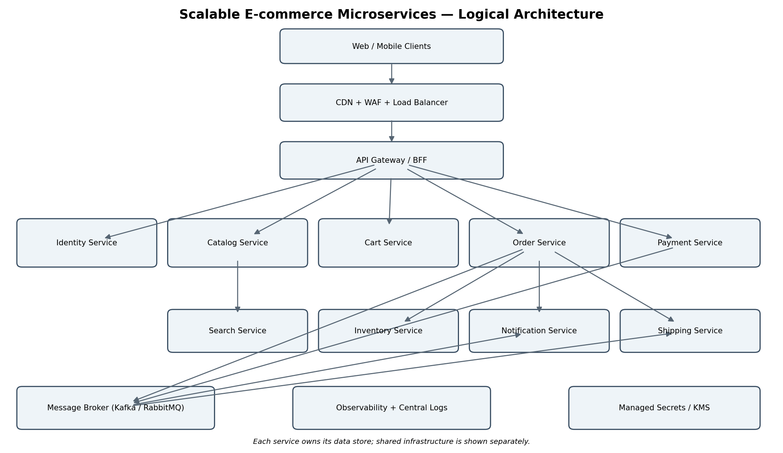
Figure 1. Logical architecture. The diagram is conceptual: each business service has its own datastore, and shared platform components provide routing, event transport, monitoring, and secret management.

1.3 Core design principles
- Domain boundaries: each microservice owns one business capability and its data.
- Database-per-service: services do not directly query another service’s database.
- API-first: REST/JSON APIs are documented with OpenAPI; internal event schemas are versioned.
- Asynchronous integration: events are used for side effects and cross-service workflows where immediate response is unnecessary.
- Stateless compute: application instances can be replaced or scaled horizontally without losing session state.
- Failure isolation: timeouts, bounded retries, circuit breakers, bulkheads, and dead-letter queues prevent cascading failures.

2. Detailed Description of Each Microservice

2.1 Identity and User Service
Responsibilities: Registration, login, email/phone verification, password reset, profile management, roles, and token/session lifecycle.
Example interfaces: POST /users, POST /auth/login, POST /auth/refresh, POST /auth/password-reset, GET/PATCH /users/me.
Data design: Relational database (PostgreSQL) for user profiles and identity metadata; passwords stored only as salted Argon2id hashes. Tokens and verification codes are short-lived.
Service-specific controls: Rate-limit login and verification endpoints, enforce MFA for administrators, use secure cookies or short-lived access tokens, and never log credentials.

2.2 Product Catalog Service
Responsibilities: Manage product names, descriptions, categories, attributes, images, prices, and publication status.
Example interfaces: GET /products, GET /products/{id}, GET /categories; admin-only create/update endpoints.
Data design: PostgreSQL for authoritative product data; object storage for images and media. Cache popular product details in Redis.
Service-specific controls: Validate all catalog input, enforce admin authorization, scan uploaded files, and invalidate cache entries after updates.

2.3 Search and Discovery Service
Responsibilities: Provide full-text search, filters, sorting, category navigation, and relevance ranking.
Example interfaces: GET /search?q=..., with optional category, price range, availability, and sort parameters.
Data design: OpenSearch or Elasticsearch index populated from catalog events. The search index is a derived, rebuildable read model.
Service-specific controls: Apply query limits, sanitize search input, restrict index access to private networks, and avoid exposing unpublished products.

2.4 Cart Service
Responsibilities: Maintain each customer’s active cart, quantities, selected variants, and cart expiry; support guest carts if required.
Example interfaces: GET /cart, POST /cart/items, PATCH /cart/items/{id}, DELETE /cart/items/{id}.
Data design: Redis for low-latency active cart state, with persistence or periodic durable snapshots according to recovery requirements. Product prices are revalidated at checkout.
Service-specific controls: Authorize cart ownership, validate quantities, set TTLs for abandoned carts, and do not trust client-supplied prices.

2.5 Order Service
Responsibilities: Create orders, manage order lifecycle, store immutable purchase snapshots, coordinate checkout, and expose order history.
Example interfaces: POST /orders, GET /orders/{id}, GET /users/me/orders, POST /orders/{id}/cancel.
Data design: PostgreSQL with transactions for order records and an outbox table for reliable event publishing.
Service-specific controls: Use idempotency keys on checkout, verify ownership on reads, enforce legal state transitions, and record audit events.

2.6 Payment Service
Responsibilities: Create payment intents, call an external payment gateway, process signed webhooks, and track authorization, capture, refund, and failure states.
Example interfaces: POST /payments/intents, POST /payments/{id}/capture, POST /payments/{id}/refund; webhook endpoint for provider events.
Data design: PostgreSQL for payment references and status. Store provider tokens and references, never raw card numbers or CVV.
Service-specific controls: Use a PCI-compliant provider-hosted checkout or tokenization, verify webhook signatures, use idempotency keys, and reconcile uncertain outcomes.

2.7 Inventory Service
Responsibilities: Maintain stock counts, reserve stock during checkout, release reservations on failure/timeout, and record adjustments.
Example interfaces: GET /inventory/{sku}, POST /inventory/reservations, POST /inventory/reservations/{id}/release.
Data design: PostgreSQL for inventory and reservation records; atomic updates or optimistic locking prevent overselling.
Service-specific controls: Restrict stock-adjustment permissions, keep an audit trail, make reserve/release operations idempotent, and alert on inventory inconsistencies.

2.8 Shipping and Fulfilment Service
Responsibilities: Create shipment requests, integrate with carriers, store tracking numbers, and publish shipment status changes.
Example interfaces: POST /shipments, GET /shipments/{id}, carrier webhook endpoints.
Data design: PostgreSQL for shipment state; event broker for status updates and integration messages.
Service-specific controls: Validate carrier callbacks, use signed requests where supported, and limit access to customer delivery details.

2.9 Notification Service
Responsibilities: Send transactional email, SMS, or push notifications for account verification, order confirmation, payment status, and shipping updates.
Example interfaces: Internal event consumers; optional POST /notifications for authorized internal callers.
Data design: Message broker for work queues and a database for delivery attempts and templates where required.
Service-specific controls: Keep sensitive data out of messages and logs, rate-limit sends, retry transient errors, and route repeated failures to a dead-letter queue.

2.10 Promotion and Pricing Service
Responsibilities: Evaluate coupons, campaign rules, discounts, tax inputs, and price calculations at checkout.
Example interfaces: POST /pricing/quote, POST /promotions/validate.
Data design: PostgreSQL for promotion rules; Redis cache for frequently used read-only rules where safe.
Service-specific controls: Validate coupon eligibility server-side, prevent replay or duplicate redemption, and log rule changes.

2.11 Service communication and ownership
Synchronous REST calls are appropriate when a client needs an immediate answer, such as product details or a cart response. Events are preferred for downstream work such as notifications, analytics, search indexing, and shipping updates. A service must not write directly to another service’s database. For events, use schema versioning and backward-compatible changes. The transactional outbox pattern helps ensure that a committed database change and its event are not silently separated by a process crash.

3. Data Flow Diagrams

3.1 User registration and sign-in
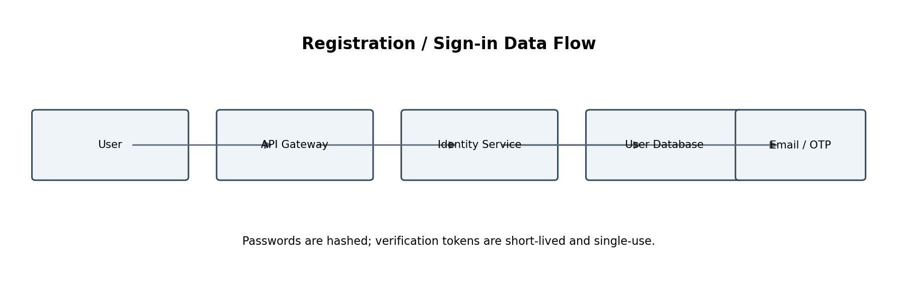
Figure 2. Registration flow. The Identity Service validates input, stores a password hash and user record, and requests verification delivery. On successful verification, the account is activated. Sign-in returns a short-lived access token and, where used, a securely rotated refresh token.

3.2 Product browsing and search
- The client requests a category or search query through the API Gateway.
- The Search Service queries its search index and returns product IDs, snippets, and facets.
- Product details are fetched from the Catalog Service or a safe cache; images are delivered from object storage/CDN.
- Catalog changes publish events that update the search index asynchronously. The index may lag briefly and can be rebuilt from the catalog.

3.3 Cart and checkout / payment flow
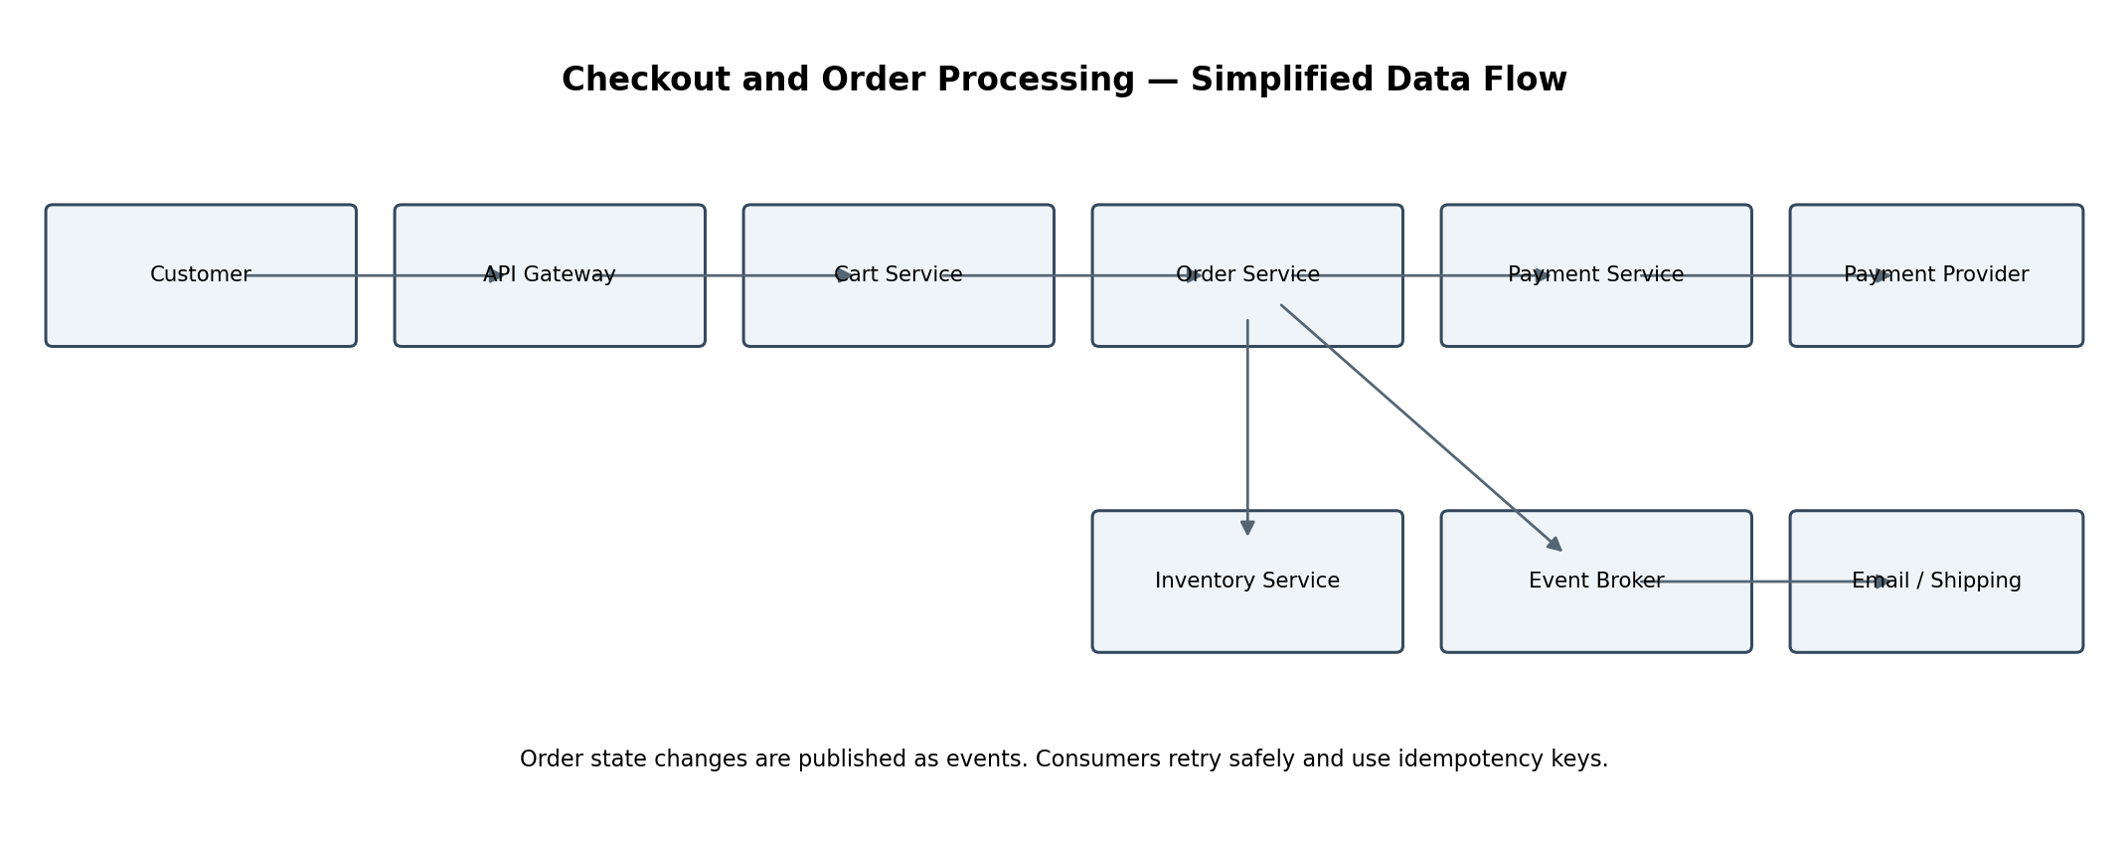
Figure 3. Checkout flow. The exact order of inventory reservation and payment authorization depends on the chosen business policy. A common approach is to validate the cart and price, reserve stock, create a pending order, authorize payment, then confirm the order and capture payment according to provider capabilities. On failure, release stock and void or refund the payment as appropriate.

3.4 Checkout sequence in detail
- Client submits checkout with an idempotency key; the gateway authenticates the customer and applies limits.
- Order Service obtains the cart and asks Pricing to validate current prices, discounts, and taxes.
- Inventory Service reserves requested SKUs atomically and returns a reservation identifier or an out-of-stock response.
- Order Service creates a PendingPayment order and records an outbox event in the same database transaction.
- Payment Service creates or confirms a payment intent with the external provider using an idempotency key.
- After a verified provider response/webhook, Order Service transitions the order to Confirmed or PaymentFailed.
- OrderCreated/OrderConfirmed events trigger notification and fulfilment workflows. Consumers deduplicate event IDs.
- If the workflow fails, a compensating action releases inventory and voids/refunds payment where needed.

3.5 Order state model
A suggested order state model is: Created → PendingPayment → Confirmed → Processing → Shipped → Delivered. Alternative terminal states include Cancelled, PaymentFailed, and RefundPending/Refunded. Only explicitly allowed transitions should be accepted; state changes should include timestamps and correlation IDs.

4. Justification of Technologies and Tools
Area | Suggested technology | Reason
Container platform | Docker + Kubernetes | Portable packaging and horizontal scaling; Kubernetes supports health checks, rolling deployments, autoscaling, and self-healing.
Edge and routing | CDN, WAF, cloud load balancer, API Gateway | Caches static content, blocks common attacks, distributes traffic, centralizes routing, authentication checks, and rate limits.
Service APIs | REST/JSON + OpenAPI | Widely supported, easy to test, and suitable for public/client-facing operations.
Event transport | Apache Kafka or managed equivalent; RabbitMQ is suitable for simpler task queues | Kafka supports durable event streams and replay; RabbitMQ is useful for work queues. Choose one primary broker to avoid unnecessary complexity.
Databases | PostgreSQL per service; Redis for cache/cart; OpenSearch for search | PostgreSQL provides transactions and constraints; Redis reduces latency for ephemeral/high-read data; OpenSearch supports full-text search.
Object storage/CDN | S3-compatible object storage + CDN | Durable, inexpensive storage for product images and efficient global delivery.
Observability | OpenTelemetry, Prometheus, Grafana, centralized logs | Metrics, distributed traces, and correlated logs make latency and failures easier to diagnose.
Secrets and encryption | Cloud KMS / secrets manager | Centralized rotation and access control for database credentials, API keys, signing keys, and certificates.
CI/CD and infrastructure | GitHub Actions/GitLab CI, Terraform, container registry | Repeatable builds, automated tests, reviewable infrastructure changes, and controlled deployments.
Payment processing | Established payment service provider with tokenization/hosted checkout | Reduces exposure to card data and delegates sensitive payment entry and processing to a specialist provider.
These are reference choices rather than mandatory products. A cloud-managed database, broker, Kubernetes service, and secrets manager can reduce operational overhead. The final selection should reflect the team’s skills, budget, regional availability, data residency requirements, and expected traffic.

5. Security Measures

5.1 Identity and access control
- Use OpenID Connect/OAuth 2.0-compatible identity flows; validate token issuer, audience, expiry, and signature.
- Apply role-based access control for customers, support staff, operators, and administrators; require MFA for privileged accounts.
- Enforce authorization in each service, not only at the gateway. Check resource ownership on orders, carts, addresses, and payment records.

5.2 Data protection
- Require TLS for client and service-to-service traffic; encrypt databases, backups, and object storage at rest.
- Keep secrets in a managed secret store and rotate them; never commit secrets to source control or container images.
- Minimize personal data, define retention/deletion rules, and redact personal or payment-related data from logs.

5.3 Payment security
- Use a compliant payment provider, hosted fields/checkout, or tokenization; do not store CVV or raw card details.
- Verify webhook signatures and timestamps, reject replayed events, and reconcile payment status against provider records.
- Use idempotency keys for create/capture/refund requests and maintain an auditable payment state machine.

5.4 Application and API protection
- Validate inputs on the server, use parameterized database queries, encode output, and protect against injection and cross-site scripting.
- Apply WAF rules, per-user and per-IP rate limits, request size limits, bot controls, and abuse monitoring.
- Use secure, HttpOnly, SameSite cookies when cookies are used; protect state-changing browser requests against CSRF.

5.5 Infrastructure and supply chain
- Run containers as non-root, use minimal base images, scan dependencies and images, and patch vulnerabilities regularly.
- Place databases and internal services on private networks; use network policies and least-privilege service identities.
- Use signed builds/artifacts where feasible, protected branches, peer review, automated tests, and separate production credentials.

5.6 Monitoring and incident response
- Record security-relevant audit events without logging passwords, tokens, full card data, or unnecessary personal details.
- Alert on unusual login failures, authorization errors, payment anomalies, elevated 5xx rates, and unexpected data access.
- Maintain an incident response plan, backup restoration tests, key-rotation procedures, and documented recovery ownership.

6. Scalability, Reliability, and Deployment

6.1 Scaling strategy
- Scale stateless service replicas horizontally using CPU, memory, request rate, or queue lag as signals.
- Cache static assets and popular catalog responses at the CDN or Redis, with explicit TTLs and invalidation rules.
- Use database indexes, connection pooling, read replicas for read-heavy workloads, and partitioning only when measured need justifies it.
- Separate search indexing and notifications from synchronous checkout so their backlogs do not block purchases.
- Set capacity limits and load-test realistic browse-to-buy traffic, flash-sale spikes, and dependency failures.

6.2 Reliability patterns
- Timeouts on every remote call; retries only for transient failures, with exponential backoff and jitter.
- Circuit breakers and bulkheads around external providers and high-risk dependencies.
- At-least-once event delivery with idempotent consumers; do not assume exactly-once end-to-end processing.
- Dead-letter queues, replay tooling, and dashboards for failed events.
- Saga-style orchestration or explicit process state for checkout, with compensating actions for reservations and payments.

6.3 Deployment and release
- Build immutable container images and deploy through CI/CD with automated unit, integration, contract, and security tests.
- Use rolling or canary deployments with health checks and automated rollback criteria.
- Manage infrastructure as code and keep development, staging, and production environments separated.
- Version APIs and events; prefer backward-compatible changes so services can be deployed independently.

6.4 Service-level objectives (initial targets)
Capability | Initial target | Measurement
Product browse/search | p95 under 300 ms (excluding large media downloads) | Gateway and service latency metrics
Cart operations | p95 under 250 ms | Cart API latency
Checkout API | p95 under 1.5 s for internal orchestration before external payment completion | Checkout trace spans
Availability | 99.9% monthly for core browse/cart APIs as a starting goal | Successful requests / eligible requests
Event processing | 95% of normal events processed within 30 seconds | Broker consumer lag and event age
These are illustrative objectives, not guarantees. Validate them through load tests and revise them based on business needs.

7. Assumptions, Risks, and Future Enhancements

7.1 Assumptions
- The platform is a single logical marketplace; multi-vendor settlement can be added as a separate domain capability.
- An external payment provider handles sensitive card entry and payment network interactions.
- The platform runs in a cloud environment with managed equivalents available for databases, storage, and messaging.
- Initial scope covers the core shopping journey; recommendations, reviews, returns, and advanced fraud detection are future capabilities.

7.2 Key risks and mitigations
Risk | Mitigation
Distributed checkout can partially fail | Use explicit order states, idempotency, outbox events, timeouts, and compensating actions.
Inventory overselling during concurrent purchases | Use atomic reservations, conditional updates, expiry, and contention/load tests.
Search index may be temporarily stale | Treat catalog as source of truth; expose freshness monitoring and rebuild support.
Too many microservices increase operational complexity | Start with clear, necessary boundaries; standardize templates, telemetry, CI/CD, and ownership.
Payment provider timeout creates an uncertain result | Query/reconcile provider state before retrying capture; reuse idempotency keys.

7.3 Future enhancements
- Recommendation service and personalization based on consented behavior.
- Returns and refunds workflow with warehouse integration.
- Fraud and risk scoring with human review for suspicious transactions.
- Multi-region disaster recovery, read locality, and regional failover if business availability requirements justify the cost.
- Analytics data pipeline using privacy-aware event processing and a warehouse/lakehouse.

Conclusion
The proposed architecture separates e-commerce capabilities into independently deployable services while preserving clear ownership of data. A gateway, caching, horizontal scaling, event-driven integration, and observability help the platform handle high traffic. Strong identity controls, encryption, provider-based payment tokenization, and idempotent checkout workflows reduce security and consistency risks. The design should be validated with threat modeling, load testing, failure-injection exercises, and operational reviews before production use.

Glossary
Term | Meaning
API Gateway | Entry point that routes client requests and applies shared policies.
CDN | Content Delivery Network; caches and serves static assets near users.
Idempotency key | A unique request identifier that prevents duplicate processing when a request is retried.
Microservice | An independently deployable service focused on a specific business capability.
Outbox pattern | A method for reliably publishing events from committed database changes.
Saga | A multi-step distributed workflow coordinated through local transactions and compensating actions.
WAF | Web Application Firewall; filters common malicious web requests.

